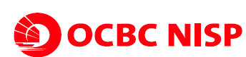 |  | Functional Specification Design
Title of Functional Specification Design | : | Update Menu SKN/RTGS/TT Via Scan di Pro Teller
Project Id | : | COPOD18193
Security / Network / Infrastructure / Application | : | Pro Teller, Pro Account

Document Change Control
Document Version | Date |  | Name | Summary of Changes
Initial Doc | 20190415 |  | Hendri Kartono | Initial Doc

Objectives
Penambahan menu baru untuk setting mapping NIK dan branch code sebagai parameter filter data serta penambahan fitur di menu SKN Completion CBO, RTGS Completion CBO, TT Completion CBO, SKN Approval CBO, RTGS Approval CBO & TT Approval CBO dengan capability
- Adanya parameter flag pending untuk pencarian data di menu SKN/RTGS/TT Completion CBO
- Adanya parameter flag pending pada saat CBO melakukan completion untuk data yang belum lengkap di menu SKN/RTGS/TT Completion CBO
- Penambahan validasi baru terkait parameter flag pending yang ada di menu SKN/RTGS/TT Completion CBO & SKN/RTGS/TT Approval CBO

Scope
Nama Aplikasi : Pro Teller & Pro Account
Database : SQL_TELLER & SQL_ACC
Middleware : TIBCO (BW)

Topology / Network / Connection
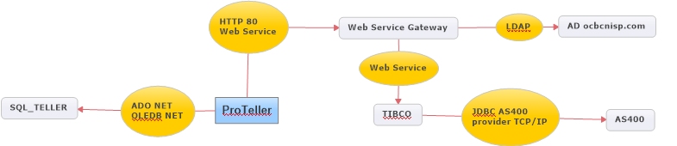

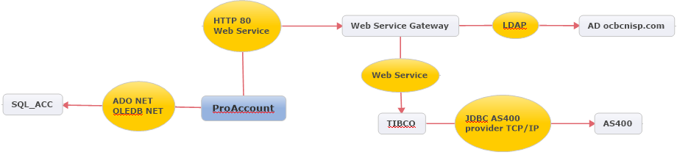

Menu relation
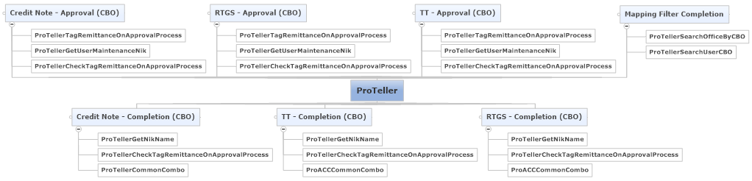

Database Diagram
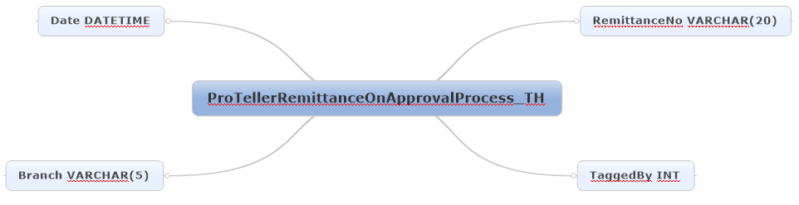
DB-NISP.SQL_TELLER.. ProTellerRemittanceOnApprovalProcess_TH
Table untuk menyimpan remittance number yang sedang di proses approve oleh approver terkait
Solution

FSD ID | BR ID | Details
FSD001 | Filter Data Completion CBO-001 | - Flow :  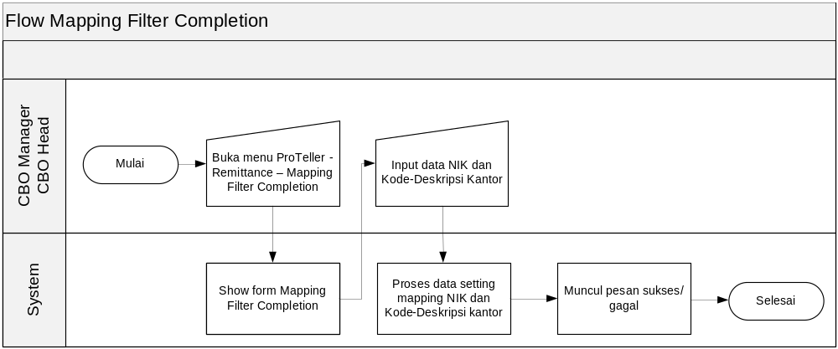  - Table Reference : Tidak ada table reference  - Store Procedure Reference : ProTellerSearchOfficeByCBO, ProTellerSearchUserCBO  - Client : frmMappingIssuanceScan.cs, ucMappingIssuanceScan.cs  - Simulation :  Input : Data setting mapping (NIK dan Kode-Deskripsi kantor)  Proses : Proses data setting mapping  Output : Data setting mapping
FSD002 | Filter Data Completion CBO-002 | - Flow :  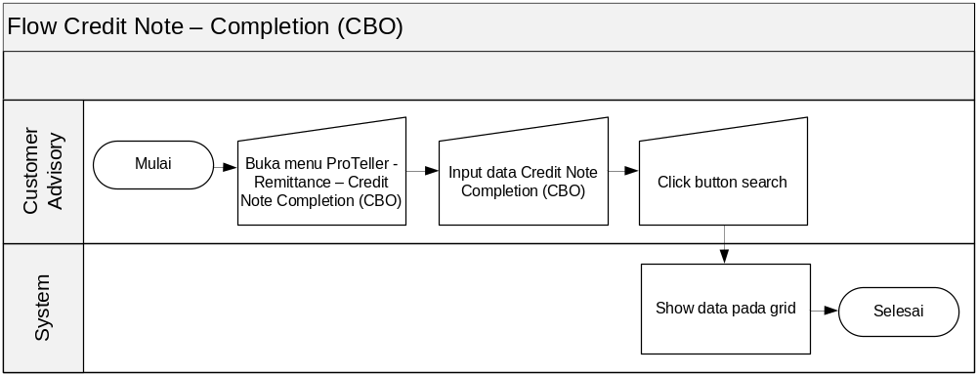  - Table Reference : Tidak ada table reference  - Store Procedure Reference : ProTellerGetNikName  - Client : frmCompletionOutwardCNCBO.cs, ucCNCompletionSubfileCBO.cs  - Simulation :  Input : Data Credit Note completion CBO  Proses : Search data Credit Note completion CBO, Proses data Credit Note completion CBO  Output : Data Credit Note completion CBO pada grid  - Flow :  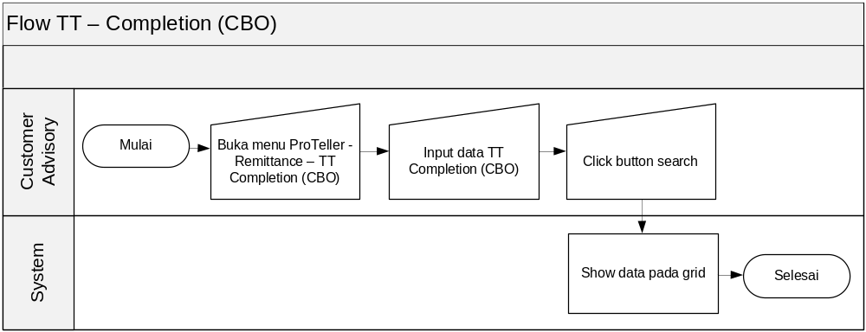  - Table Reference : Tidak ada table reference  - Store Procedure Reference : ProTellerGetNikName  - Client : frmRMOutwardTTCompletionCBOSub.cs, ucRMOutwardTTCompletionCBOSub.cs  - Simulation :  Input : Data TT completion CBO  Proses : Search data TT completion CBO, Proses data TT completion CBO  Output : Data TT completion CBO pada grid  - Flow :  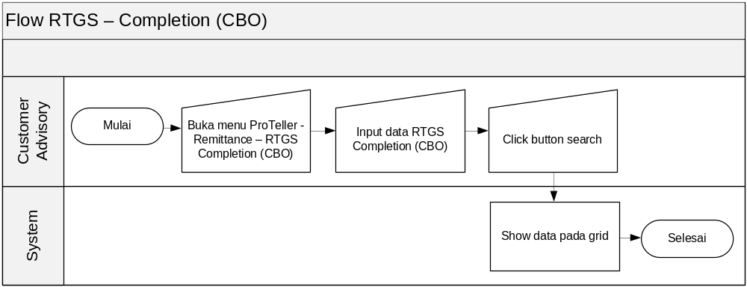  - Table Reference : Tidak ada table reference  - Store Procedure Reference : ProTellerGetNikName  - Client : frmOutwardRTGSCompletionCBOSubfiLeRMDateSub.cs, ucOutwardRTGSCompletionCBOSubfiLeRMDateSub.cs  - Simulation :  Input : Data RTGS completion CBO  Proses : Search data RTGS completion CBO, Proses data RTGS completion CBO  Output : Data RTGS completion CBO pada grid  - Flow :  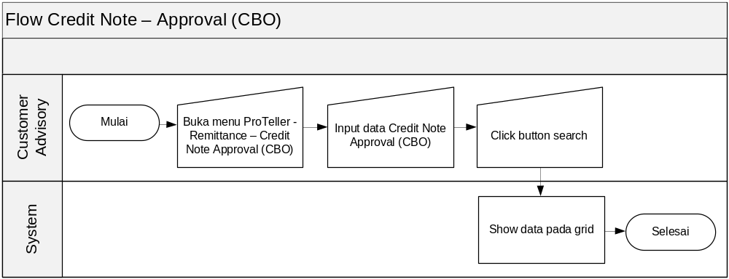  - Table Reference : Tidak ada table reference  - Store Procedure Reference : ProTellerGetUserMaintenanceNik  - Client : frmApprovalOutwardCNCBO.cs, ucApprovalOutwardCNCBO.cs  - Simulation :  Input : Data Credit Note approval CBO  Proses : Search data credit note approval CBO, Proses data Credit Note approval CBO  Output : Data Credit Note approval CBO pada grid  - Flow :  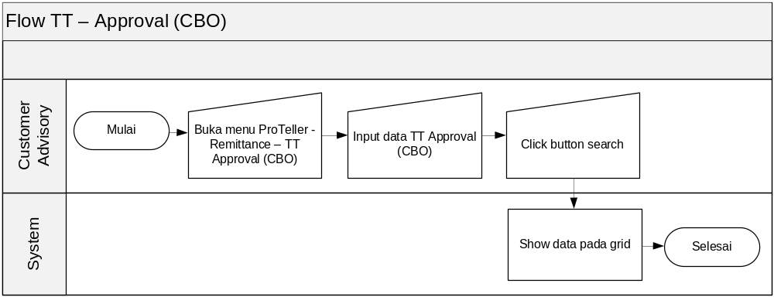  - Table Reference : Tidak ada table reference  - Store Procedure Reference : ProTellerGetUserMaintenanceNik  - Client : frmApprovalOutwardTTCBO.cs, ucApprovalOutwardTTCBO.cs  - Simulation :  Input : Data Credit Note approval CBO  Proses : Search data TT approval CBO, Proses data Credit Note approval CBO  Output : Data Credit Note approval CBO pada grid  - Flow :  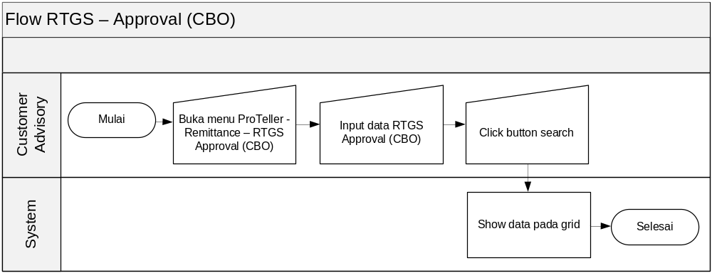  - Table Reference : Tidak ada table reference  - Store Procedure Reference : ProTellerGetUserMaintenanceNik  - Client : frmApprovalOutwardRTGSCBO.cs, ucApprovalOutwardRTGSCBO.cs  - Simulation :  Input : Data Credit Note approval CBO  Proses : Search data RTGS approval CBO, Proses data Credit Note approval CBO  Output : Data Credit Note approval CBO pada grid
FSD005 | Flag Pending_001 | - Flow :  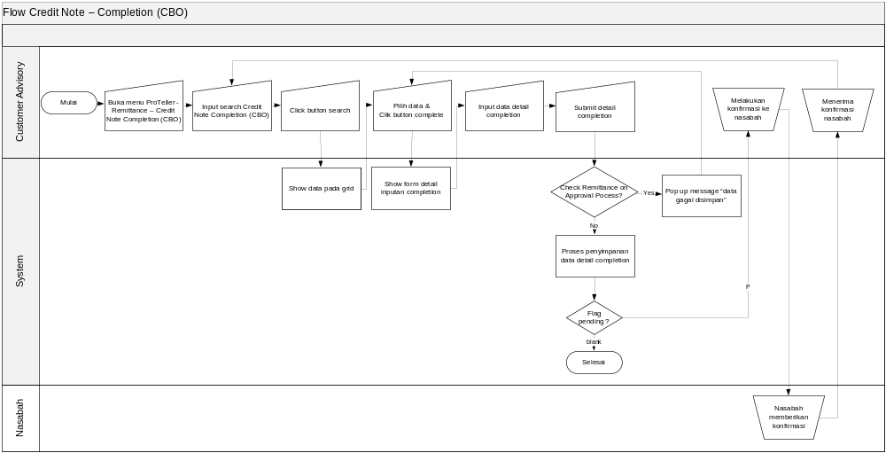  - Table Reference : Tidak ada table reference  - Store Procedure Reference : ProTellerCheckTagRemittanceOnApprovalProcess  - Client : frmCompletionOutwardCNCBO.cs, ucCNCompletionSubfileCBO.cs  - Simulation :  Input : Data detail CN completion CBO  Proses : Search data CN completion CBO, Input data detail CN completion CBO, Proses data detail CN completion CBO  Output : Data grid CN Completion CBO terupdate  - Flow :  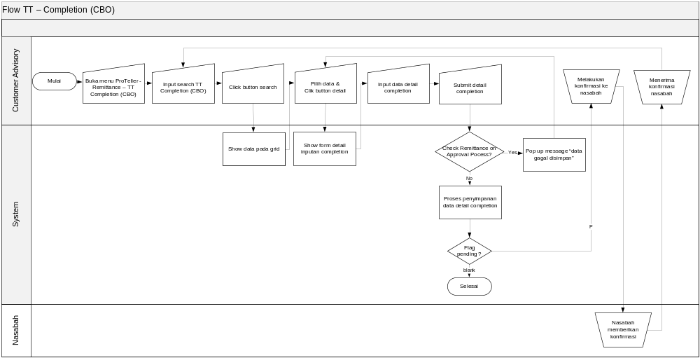  - Table Reference : Tidak ada table reference  - Store Procedure Reference : ProTellerCheckTagRemittanceOnApprovalProcess  - Client : frmRMOutwardTTCompletionCBOSub.cs ,ucRMOutwardTTCompletionCBOSub.cs, frmRMOutwardTTCompCBOCVR.cs, frmRMOutwardTTCompletionCBO.cs  - Simulation :  Input : Data detail TT completion CBO  Proses : Search data TT completion CBO, Input data detail TT completion CBO, Proses data detail TT completion CBO  Output : Data TT Completion CBO terupdate  - Flow :  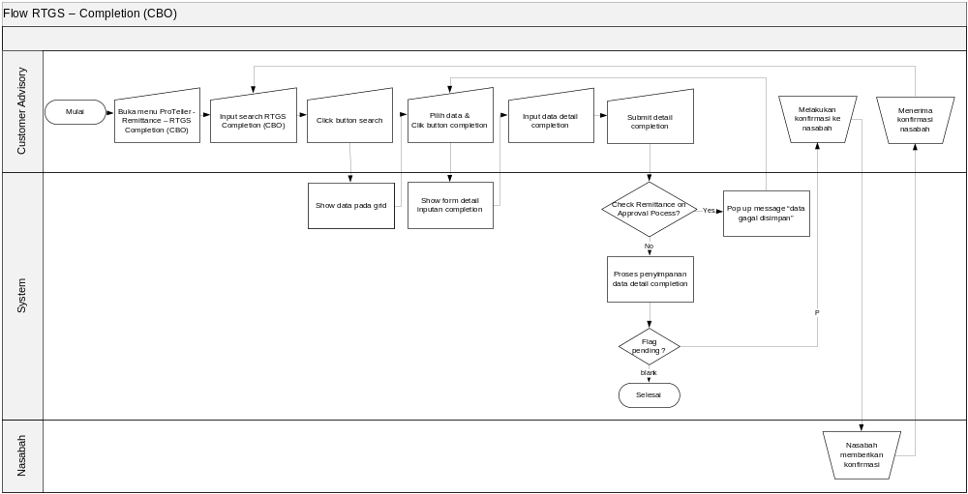  - Table Reference : Tidak ada table reference  - Store Procedure Reference : ProTellerCheckTagRemittanceOnApprovalProcess  - Client : frmOutwardRTGSCompletionCBOSubfiLeRMDateSub.cs, ucOutwardRTGSCompletionCBOSubfiLeRMDateSub.cs, frmOutwardRTGSCompletionCBODetailInq.cs, ucOutwardRTGSCompletionCBODetailInq.cs  - Simulation :  Input : Data detail RTGS completion CBO  Proses : Search data RTGS completion CBO, Input data detail RTGS completion CBO, Proses data detail RTGS completion CBO  Output : Data RTGS Completion CBO terupdate
FSD003 | Validasi Completion_001 | - Flow :  - Table Reference : Tidak ada table reference  - Store Procedure Reference : ProTellerCheckTagRemittanceOnApprovalProcess  - Client : frmCompletionOutwardCNCBO.cs, ucCNCompletionSubfileCBO.cs  - Simulation :  Input : Data detail CN completion CBO  Proses : Search data CN completion CBO, Input data detail CN completion CBO, Check remittance on approval process, Proses data detail CN completion CBO  Output : Data CN Completion CBO terupdate  - Flow :  - Table Reference : Tidak ada table reference  - Store Procedure Reference : ProTellerCheckTagRemittanceOnApprovalProcess  - Client : frmRMOutwardTTCompletionCBOSub.cs ,ucRMOutwardTTCompletionCBOSub.cs, frmRMOutwardTTCompCBOCVR.cs, frmRMOutwardTTCompletionCBO.cs  - Simulation :  Input : Data detail TT completion CBO  Proses : Search data TT completion CBO, Input data detail TT completion CBO, Check remittance on approval process, Proses data detail TT completion CBO  Output : Data TT Completion CBO terupdate  - Flow :  - Table Reference : Tidak ada table reference  - Store Procedure Reference : ProTellerCheckTagRemittanceOnApprovalProcess  - Client : frmOutwardRTGSCompletionCBOSubfiLeRMDateSub.cs, ucOutwardRTGSCompletionCBOSubfiLeRMDateSub.cs, frmOutwardRTGSCompletionCBODetailInq.cs, ucOutwardRTGSCompletionCBODetailInq.cs  - Simulation :  Input : Data detail RTGS completion CBO  Proses : Search data RTGS completion CBO, Input data detail RTGS completion CBO, Check remittance on approval process, Proses data detail RTGS completion CBO  Output : Data RTGS Completion CBO terupdate
FSD004 | Approval CBO_001 | - Flow :  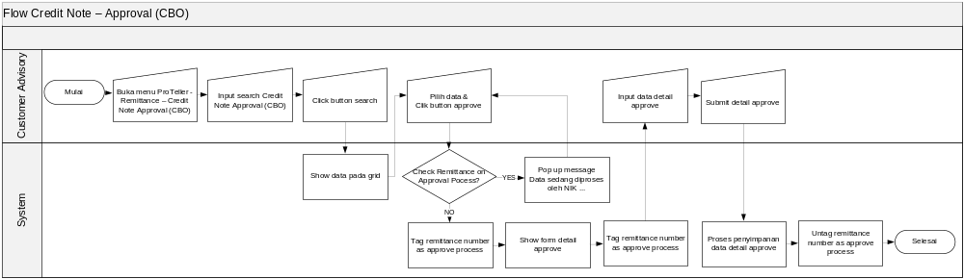  - Table Reference : ProTellerRemittanceOnApprovalProcess_TH  - Store Procedure Reference : ProTellerTagRemittanceOnApprovalProcess, ProTellerCheckTagRemittanceOnApprovalProcess  - Client : frmApprovalOutwardCNCBO.cs, ucApprovalOutwardCNCBO.cs  - Simulation :  Input : Data detail Credit Note approve CBO  Proses : Search data Credit Note approve CBO, input data detail Credit Note approve CBO, check tag remittance on approve process, tag remittance on approve proses, release tag remittance on approve proses, proses data detail Credit Note approve  Output : Data Credit Note approve CBO terupdate  - Flow :  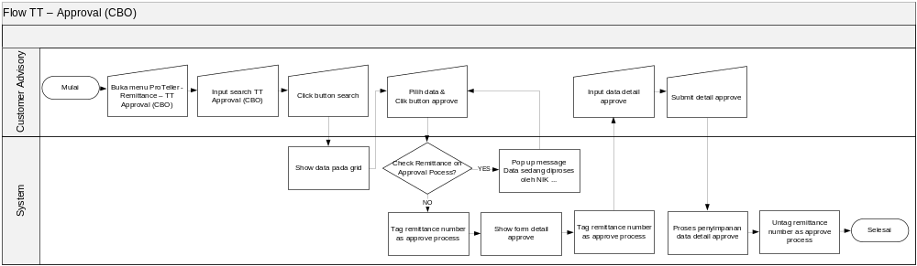  - Table Reference : ProTellerRemittanceOnApprovalProcess_TH  - Store Procedure Reference : ProTellerTagRemittanceOnApprovalProcess, ProTellerCheckTagRemittanceOnApprovalProcess  - Client : frmApprovalOutwardCNCBO.cs, ucApprovalOutwardCNCBO.cs  - Simulation :  Input : Data detail Credit Note approve CBO  Proses : Search data Credit Note approve CBO, input data detail Credit Note approve CBO, check tag remittance on approve process, tag remittance on approve proses, release tag remittance on approve proses, proses data detail Credit Note approve  Output : Data Credit Note approve CBO terupdate  - Flow :  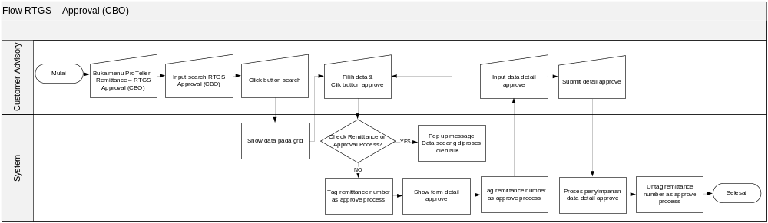  - Table Reference : ProTellerRemittanceOnApprovalProcess_TH  - Store Procedure Reference : ProTellerTagRemittanceOnApprovalProcess, ProTellerCheckTagRemittanceOnApprovalProcess  - Client : frmApprovalOutwardRTGSCBO.cs, ucApprovalOutwardRTGSCBO.cs  - Simulation :  Input : Data detail RTGS approve CBO  Proses : Search data RTGS approve CBO, input data detail RTGS approve CBO, check tag remittance on approve process, tag remittance on approve proses, release tag remittance on approve proses, proses data detail RTGS approve  Output : Data RTGS approve CBO terupdate

Job / Batch
Parameter

Attachment (s)

Test Scenario

Others Information
Prepared by, | Verified by, |  |  |  |  | Approved by,
Hendri Kartono | Melisa Amin |  |  | [Name] |  | Indra Wijaya
System Analyst | Business Analyst |  |  | Project Manager |  | LOB Manager

